Prompt Engineering Task
Prompt 1:
Create a clean, educational, AI-generated image.
Subject: Machine Learning
Chapter: Introduction to Machine Learning
Lesson title: What Is Machine Learning?
Target audience: beginner

Style guidelines:
Professional, neutral, and classroom-friendly
Simple, clear visuals that represent the main idea of the lesson
No text, letters, numbers, or labels should be inside the image
Soft, even lighting; no distracting background details
Illustration or vector-art style, not photorealistic
Horizontal (landscape) orientation.

The image should visually explain the core concept of “What Is Machine Learning?” in a way that is easy for beginners to understand at a glance.

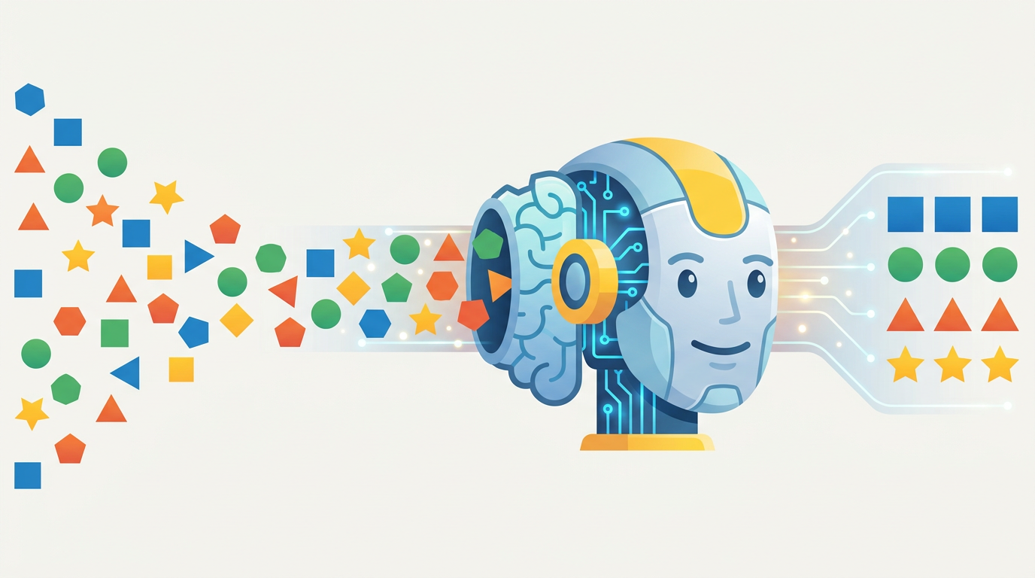
Output:

Prompt 2:
Write a voice-over script for an educational image i have attached:
Subject: Machine Learning
Chapter: Introduction to Machine Learning
Lesson title: What Is Machine Learning?
Target audience: beginner

Constraints:
Use simple English, short sentences, and everyday words
Duration: 60–90 seconds when read at a normal speaking pace (about 150–220 words)
Begin with a friendly introduction that names the lesson topic
Clearly explain what is shown in the image, describing the main elements and how they relate to the lesson concept
No technical jargon; if a concept is new, explain it in plain language
Use an encouraging, calm teaching tone
End with a short, simple summary (1–2 sentences) of the key idea

The script should sound natural when read aloud and help a beginner understand the lesson concept just by listening while looking at the image.

Output:
Hello and welcome to this lesson: What Is Machine Learning?
Take a look at the image. On the left side, we see many different shapes and colors. There are circles, squares, triangles, stars, and other shapes mixed together. These represent information, or data, coming from the world around us.
In the center, there is a robot-like brain. Think of this as a machine learning system. The shapes move into the machine, and the machine studies them. It looks for patterns and learns from the examples it receives.
On the right side, the shapes are no longer mixed together. They are neatly grouped by type. The squares are together, the circles are together, the triangles are together, and the stars are together. This shows how machine learning can organize information and make sense of large amounts of data.
Machine learning works in a similar way. Instead of being given every rule by a person, a computer learns from examples. The more examples it sees, the better it can recognize patterns and make decisions.
To sum up, machine learning is a way for computers to learn from data. It helps computers find patterns, organize information, and make useful predictions or decisions.

Prompt 3:
Converted the above script in Inworld AI (text to speech):

**[Warmly]** Hello and welcome to this lesson: **What Is Machine Learning?**

**[Pause]**

Take a look at the image.

**[Pause]**

On the left side, we see **many different shapes and colors**.

There are circles, squares, triangles, stars, and other shapes mixed together.

**[Pause]**

These represent **information**, or **data**, coming from the world around us.

**[Pause]**

In the center, there is a **robot-like brain**.

**[Pause]**

Think of this as a **machine learning system**.

The shapes move into the machine, and the machine studies them.

**[Slowly]**

It looks for **patterns** and learns from the **examples** it receives.

**[Pause]**

On the right side, the shapes are **no longer mixed together**.

They are neatly grouped by type.

The squares are together, the circles are together, the triangles are together, and the stars are together.

**[Pause]**

**[Emphasize]** This shows how machine learning can **organize information** and make sense of **large amounts of data**.

**[Pause]**

Instead of being given every rule by a person, a computer learns from **examples**.

**[Pause]**

The more examples it sees, the better it can **recognize patterns** and **make decisions**.

**[Pause]**

**[Emphasize]** To sum up, machine learning is a way for computers to **learn from data**.

It helps computers find patterns, organize information, and make useful predictions or decisions.

**[Final Pause]**

Output:

Task_3_video_link

